FLEX BUILDER

Flex Builder -----------------------------------------------------------------------------------------1
Prerequisites ------------------------------------------------------------------------------------------1
Flex builder installation-----------------------------------------------------------------------------1

Installing the Flash CS3-----------------------------------
Creating objects in Flash-------------------------------
Integrating with QTP
Cautions to be taken before Addin to QTP---------------------------------------------------------
Embeding the objects in flash with flex
Running the scripts
Recording or Object Spy form QTP
Flex objects recognition

FLEX- QTP AUTOMATION

- FLEX:

- Flex is a free, open source framework for building highly interactive, expressive web applications that deploy consistently on all major browsers, desktops, and operating systems.

- It provides a modern, standards-based language and programming model that supports common design patterns.

- MXML, a declarative XML-based language, is used to describe UI layout and behaviors, and Action Script™ 3, a powerful object-oriented programming language, is used to create client logic.

- Flex also includes a rich component library with more than 100 proven, extensible UI components for creating rich Internet applications (RIAs), as well as an interactive Flex application debugger.

- PRE-REQUISITIES:
To use Flex Automated Testing with the Flex 3 Plug-in for HP QuickTest Professional, we have installed the below mentioned softwares.
- Mercury QuickTest Professional 9.0’s or later
- Adobe Flex 3 Plug-in for Mercury QuickTest Pro
- Microsoft Internet Explorer, version 6 or later
- Flash Player ActiveX control

FLEX BUILDER INSTALLATION:

INSTALALTION PROCESS :
Flex 3 Plug-in for HP QuickTest Professional .
To use Flex Automated Testing with the Flex 3 Plug-in for HP QuickTest Professional (formerly Mercury QuickTest Pro), you must perform additional steps. The rest of this section describes how to install and use the Flex 3 Plug-in for HP QuickTest Professional.
Requirements for Using the QTP Plug-in .
To test applications with Flex Automated Testing and the QTP agent, you must install the following:
• Mercury QuickTest Professional 9.1 (no support for Smart Identification), available from Mercury
• Mercury QuickTest Professional 9.2 and patch 1701 or later if you want Smart Identification support
• Adobe Flex 3 Plug-in for Mercury QuickTest Pro
• Microsoft Internet Explorer, version 6 or later
• Flash Player ActiveX control, version 9.0.28.0 or higher
Installing the Plug-in
This section describes the steps necessary for a QC testing professional to configure QTP to work with Flex applications. You must install QTP and the plug-in.
To install QTP:
1. Install Flash Player 9 ActiveX control (9.0.28.0 or higher) for Microsoft Internet Explorer. This is currently the only supported browser/player.
2. Install QTP 9.1 if you do not require support for Smart Identification. If you want to use Smart Identification, install QTP 9.2 and patch 1701. You must get QTP 9.1 from Mercury.
3. If you are using Mercury QTP on Microsoft Windows Vista you need to turn off the User Account Control (UAC) feature. Instructions to turn off UAC are available here
4. Restart your computer.
To install the Flex 3 Plug-in for Mercury QuickTest Pro:
1. Run the flex_builder_root/Installers/QTP_Plugin_Installer.exe.
2. Start QTP.
3. Close QTP.
In addition to the plug-in's DLLs and XML files, the plug-in installer includes the following in the installation directory:
• /demo — Contains a Flash movie that describes the basics of using the plug-in. Be sure to enable audio on your computer.
• /Uninstall Adobe Flex 3 Plug-in for Mercury QuickTest Pro — Contains the uninstaller.
Using the Plug-in
1. Start QTP again after installing the plug-in. The Add-in Manager lists the Flex plug-in.
2. Select the Flex plug-in in the Add-in Manager.
3. Select New > Test and click the Record button.
NOTE: Flex application testing with QTP currently supports only Microsoft Internet Explorer with the ActiveX Flash Player.
For more information on these tasks and using QTP to test Flex applications, see Testing with QTP.
For information on the operations and properties of Flex objects in QTP, see QTP Object Type Information.

Installing the Flash CS3
Adobe Flash CS3 Download
 | Write a review  Email this to a friend  Report a bad link
  Publisher: | Macromedia
  Last updated: | July 27, 2007
  File Size: | 110 MB
  OS Support: | Windows (all)
  License: | Shareware
  Downloads: | 40204
  User Rating: | 4.83 / 5 (321 Votes)
  Top of Form
  Bottom of Form
Publisher's Description
Industry's most advanced authoring environment for creating interactive websites, digital experiences and mobile content.
CREATE AND DELIVER INTERACTIVE CONTENT
Enjoy a fast, fluid workflow with Adobe® Flash® CS3 Professional software, featuring a streamlined user interface, advanced video tools, and impressive integration with related software.
Reasons to upgrade
* Adobe Photoshop® and Illustrator® import
* Animation conversion to ActionScript™
* Adobe interface
* ActionScript 3.0 development
* Advanced debugger
* Adobe Device Central CS3
* Rich drawing capabilities
* User interface components
* Advanced QuickTime export
* Sophisticated video tools
* Timesaving coding tools

Creating objects in Flash

Flex Tutorial - Runtime Button Icons using Flash symbols

So to get the the new year started off I decided to write a quick tutorial about two items that almost any Flex programmer can take advantage of. One is how to change the icon on a button at runtime and the other is using symbols in a flash .swf file for those icons. The major advantage of using the symbols is that you can use a single flash file to hold all the icons you need for your application. And what application wants to have completely static icons on their buttons? Ok, probably most, but we will ignore the nay sayers so that we can have some fun.
Let's take look at a quick example that shows what we will be learning in this tutorial. We have a very simple application below that has a single large button in the middle that changes its icon. The icon is chosen randomly from three that we have, which were all embedded from a single flash .swf file. Well, what are you waiting for? Start clicking. Also feel free to right click and grab the source files.

The first thing we are going to create the flash .swf file. I built my icons in Flash CS3. Once you open up Flash you can draw your first shape. Below is quick screenshot of Flash with a simple shape drawn.
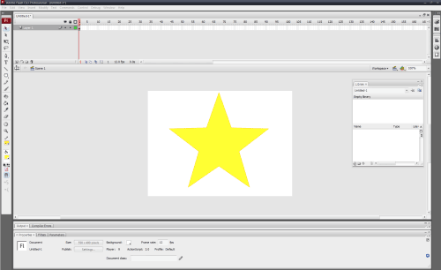
Once we have the shape we can convert it to a symbol by selecting the entire object and right clicking and going down to "Convert to Symbol", image below. Then a window will pop up, in which we will put the name of the symbol. We also at this point click the check box about half way down to export to actionscript and give the symbol a class name. This will enable us to use the class name in Flex to embed the specific symbol. Images for both steps are below.
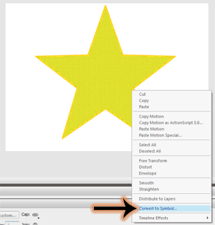

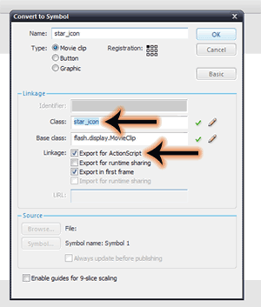
Once we have all that done you can build some more symbols, and once we have all our symbols built we now publish the .swf file by going to file->publish. Now that we have our .swf with our symbols in it we can start building the Flex application.
The first thing we do is build the basic application using a panel, a couple text components and a single button. The text components just hold the informational stuff in the application. And I like using a panel for the nice title header. The button is the component we are going to use throughout the tutorial so I gave it an id also. You can see this below.
<?xml version="1.0" encoding="utf-8"?>
<mx:Application xmlns:mx="http://www.adobe.com/2006/mxml"
layout="absolute" width="300" height="300">
<mx:Panel x="0" y="0" width="100%" height="100%"
layout="absolute" title="Changing Button Icons on the Fly">
<mx:Text x="10" y="10" width="260" height="53"
fontSize="18" fontFamily="Arial">
<mx:text>
Click the button below to change the icon displayed on it
</mx:text>
</mx:Text>
<mx:Button id="but" x="80" y="71" width="120" height="120"/>
<mx:Text x="5" y="214" fontSize="9" height="36" width="270">
<mx:text>
A random icon is chosen each time the button is clicked
</mx:text>
</mx:Text>
</mx:Panel>
</mx:Application>

Integrating with QTP &Cautions to be taken before Addin to QTP

CAUTION: Do not install the plug-in version of Flex Builder 3 into a copy of Eclipse that is already hosting Flex Builder 2 plug-in. If you want to continue running Flex Builder 2 plug-in, download a new copy of Eclipse, and use that when installing Flex Builder 3 plug-in. In addition, be sure to use separate Eclipse workspaces for each installation of Flex Builder plug-in.
1. Log in as the Windows Administrator or as a computer administrator (a user account with administrator privileges).
Note: If you attempt to install without administrator privileges, the installation will complete with flagged issues. However, you will have installed an incomplete version of Flex Builder that you will not be able to run.
The above statement is described based on the Experience

CREATING THE APPLICATION IN FLEX BUILDER
Giridhar Include this process

Embeding the objects in flash with flex
Next we will add some script to embed the icons we are going to use. We do this by adding a <Script> tag to the top of the application and adding our three private variables for the icons. To embed a .swf symbol we use an Embed tag above our private var which is of Class type. There are two ways we can embed the symbol. The first method is [Embed(source='assets/button_icons.swf', symbol='square')] which will use the .swf file and pull out the specified symbol; the second method is a shorthand which is [Embed(source='assets/button_icons.swf#square')] which uses the # to specify the symbol. In this application we use the shorthand method and the <Script> is below.
<mx:Script>
<![CDATA[
[Embed(source='assets/button_icons.swf#square')]
private var icon0:Class;
[Embed(source='assets/button_icons.swf#circle')]
private var icon1:Class;
[Embed(source='assets/button_icons.swf#star')]
private var icon2:Class;
]]>
</mx:Script>
The next thing we need to do is initialize the button icon, and we use the icon style to do this. To initialize it we add the icon style to the mxml component declaration by setting the icon attribute to {icon1}. We also want to capture the click event for this button, so we set it to a function which called updateIcon. The updated button mxml is below.
<mx:Button id="but" x="80" y="71" width="120" height="120"
icon="{icon1}" click="{updateIcon()}"/>
Now we just need to write the updateIcon function. This function will update the icon style on the button to switch it to a random icon. We do this by creating a random number between 0 and 2. Once we have the random number we can use the setStyle function on the button to change the icon style. You can see the new function below.
private function updateIcon():void
{
var iconNum:int = Math.round(Math.random() * 2);
but.setStyle("icon", this["icon" + iconNum]);
}
And that pretty much takes care of it. Nothing that complex but the concepts can be used all over the place and can be very useful. Here is the full source code:
<?xml version="1.0" encoding="utf-8"?>
<mx:Application xmlns:mx="http://www.adobe.com/2006/mxml"
layout="absolute" width="300" height="300">
<mx:Script>
<![CDATA[
[Embed(source='assets/button_icons.swf#square')]
private var icon0:Class;
[Embed(source='assets/button_icons.swf#circle')]
private var icon1:Class;
[Embed(source='assets/button_icons.swf#star')]
private var icon2:Class;
private function updateIcon():void
{
var iconNum:int = Math.round(Math.random() * 2);
but.setStyle("icon", this["icon" + iconNum]);
}
]]>
</mx:Script>
<mx:Panel x="0" y="0" width="100%" height="100%"
layout="absolute" title="Changing Button Icons on the Fly">
<mx:Text x="10" y="10" width="260" height="53"
fontSize="18" fontFamily="Arial">
<mx:text>
Click the button below to change the icon displayed on it
</mx:text>
</mx:Text>
<mx:Button id="but" x="80" y="71" width="120" height="120"
icon="{icon1}" click="{updateIcon()}"/>
<mx:Text x="5" y="214" fontSize="9" height="36" width="270">
<mx:text>
A random icon is chosen each time the button is clicked
</mx:text>
</mx:Text>
</mx:Panel>
</mx:Application>
If anyone has any questions or thoughts please just drop a comment. I hope everyone can take away a little bit from this.

Running the scripts

Run the Script in the Flex builder .The output of the application can be viewed through web or through desktop options

Recording or Object Spy form QTP & Flex objects recognition

After the application has been developed through we or thoruugh desktop .
Record the properties of the objects through QTP
Try capturing the properties with OBJECT SPY
The Class name should be FLEX BUTTON if we take the property of the object

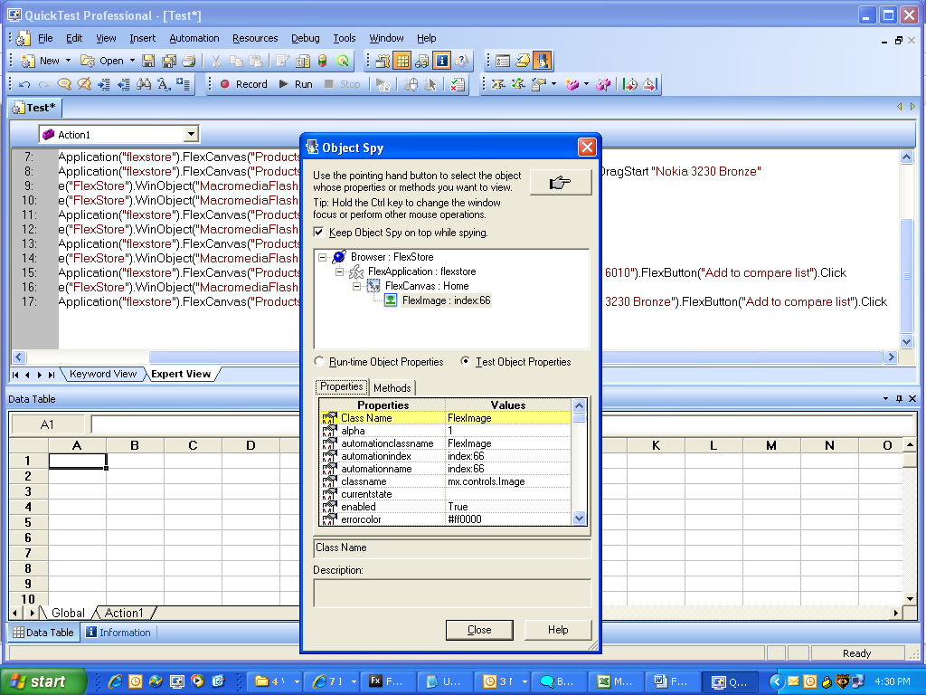

****************---------------------------------END--------------------*****************

