Issue Description

- Access the citrix applications as in the screen below.
- Access the following applications marked in blue (QTP10.0, SAP 7.20). This is displayed on a web page.

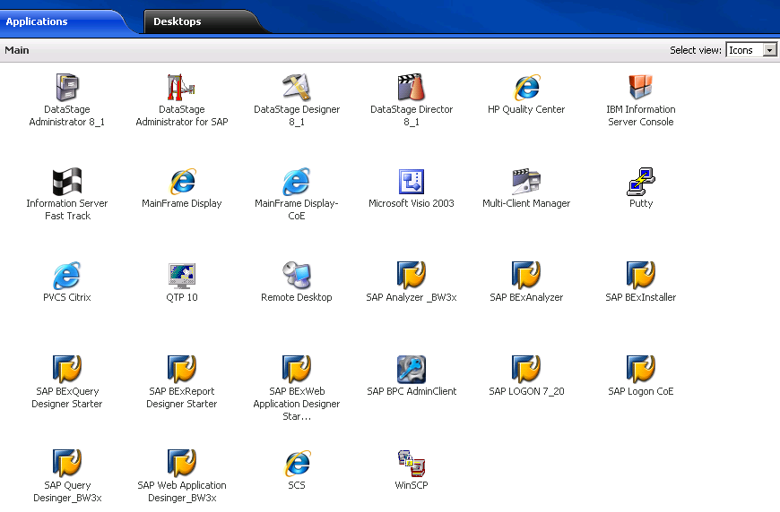

2) Open the QTP Automation Tool and Open SAP7.20 one after the other clicking on the highlighted icons.

3) From the QTP Tool click on the Record button and move the mouse pointer on the SAP window and enter RQ3 in the text box provided. QTP is expected to generate a recorded script as an indication that objects on the SAP window are recognized. This is not happening.

Note:- The icons in the above screen might have been on other machines/terminals which does not allowing QTP to recognize SAP Screens/windows during a Script Recording session.

Requirement

- QTP Tool and SAP GUI to be made availabe on a single desktop(Remote Desktop) for all the citrix credendials along with the SAP 7.20 Plugins/Patches installed.
- Similary we will need Quality Center also to be accessible through QTP to establish connection between both to save and execute automated test scripts on SAP GUI.

