Screen shot before execution of script.
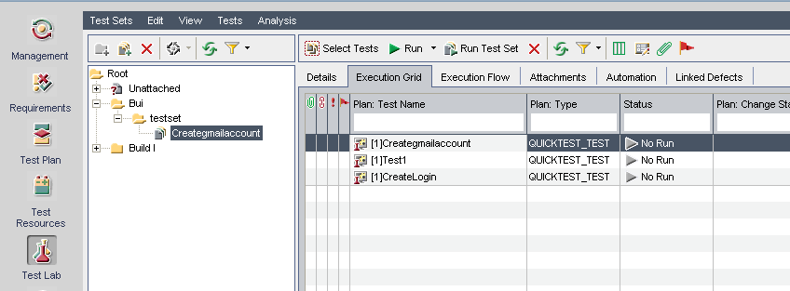

Screen shot after execution of script in qtp, Status is changed to passed. However the code(inside the createlogin) is not executing(I feel so) as duration is showing as 0.Kindly explain

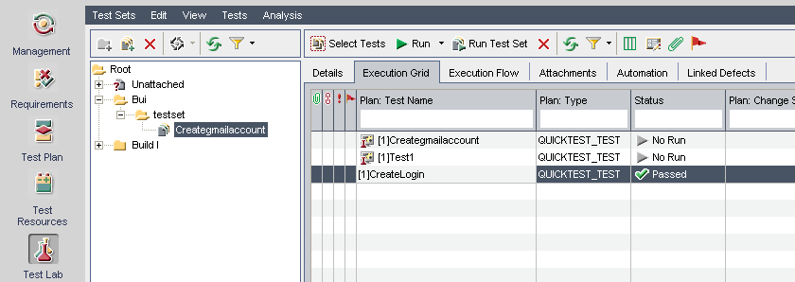
By double clicking the testname,and clicking on Launch report ,it is giving the below error. I am missing something… and also the duration is showing as 0.
