File Download dialog and button issues
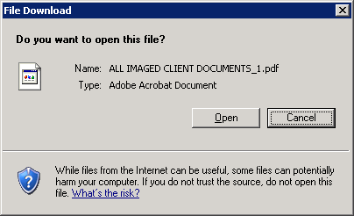
.Dialog("text:=File Download","window id:=1","index:=1").Highlight 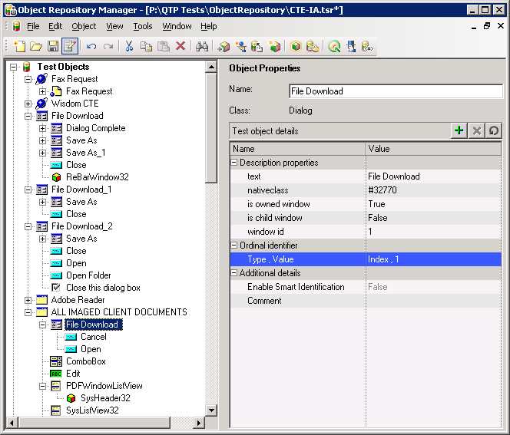

.WinButton("text:=/&Open","nativeclass:=button").Click "Open"