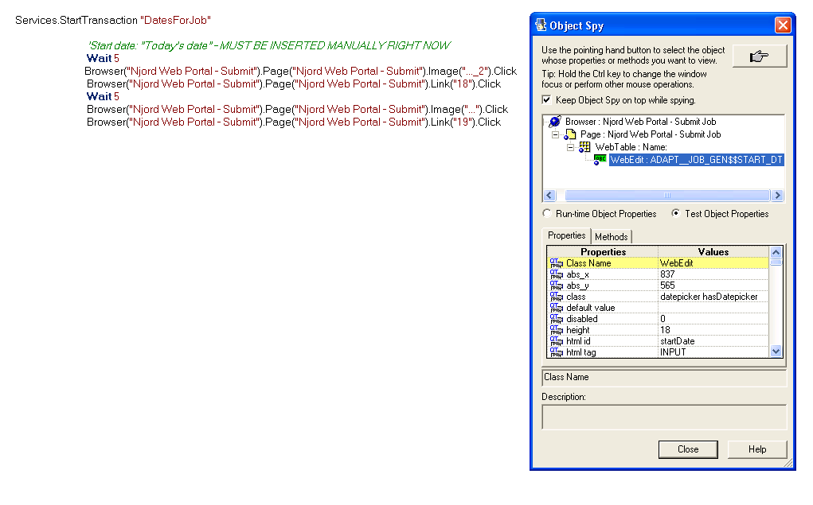
First two lines = set date 18th of April

Last two lines = set date 19th of April

In this case I wanted to have today’s date + 1 date (was created yesterday)
Below you see that I have record a manually stated of date in the calendar

