Based on the Commodity Category selected, Following Checkboxes and Edit boxes are filtered. This can vary anywhere from 1 to n.

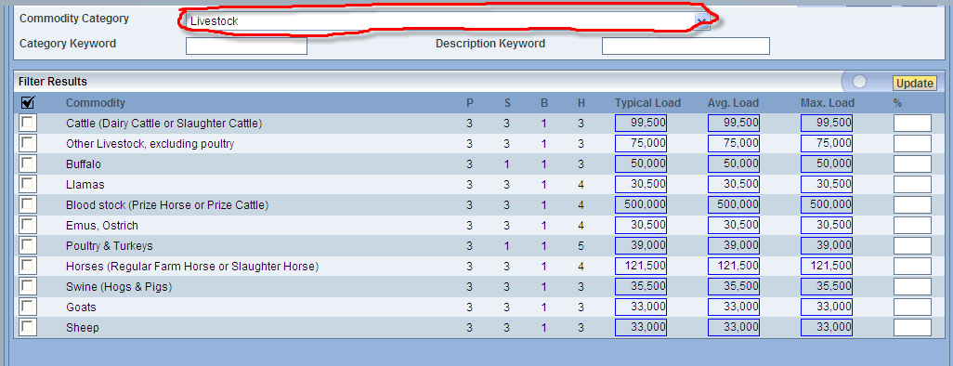

ObjectSpy of the 1st check box and it’s parent
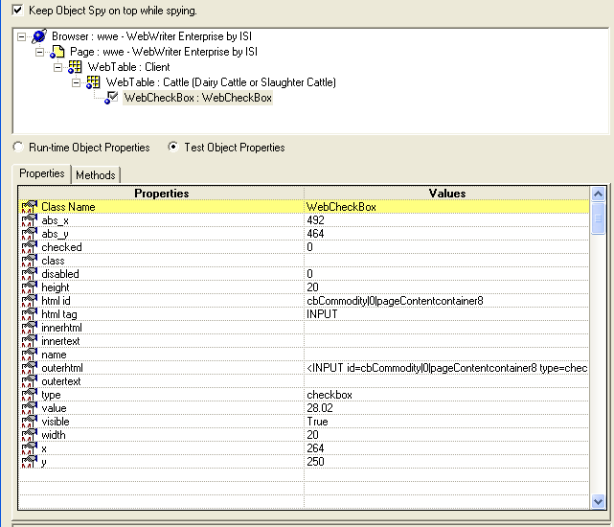

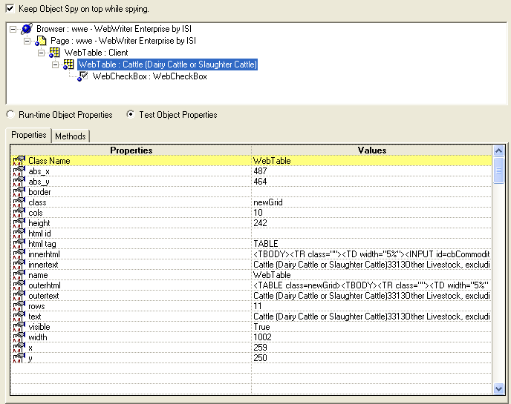

ObjectSpy of the 1st WebEdit and it’s parent
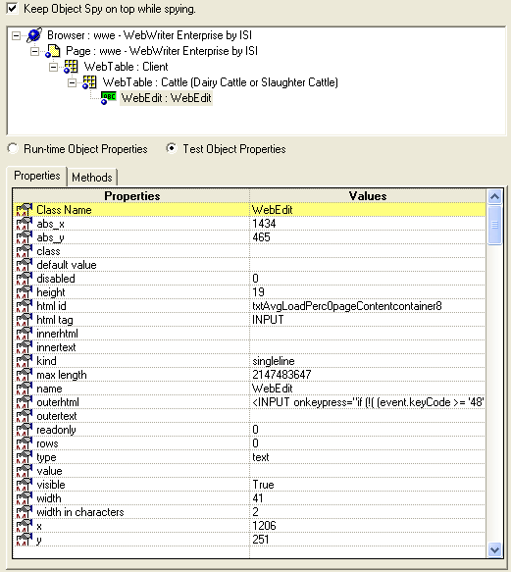

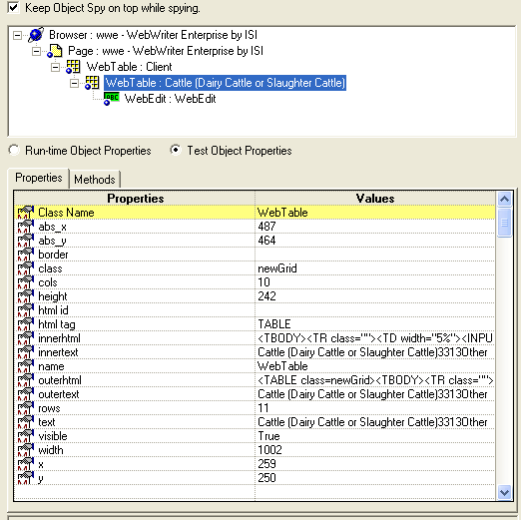

OUTPUT from Code 1:
