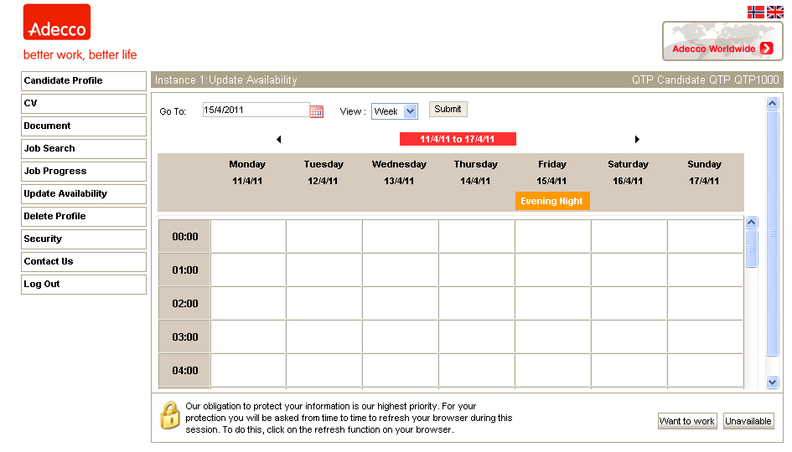
You can’t set the date, you have to click on the Calendar image and select dates from there., see next page

