Scripts runs « slowly » when :

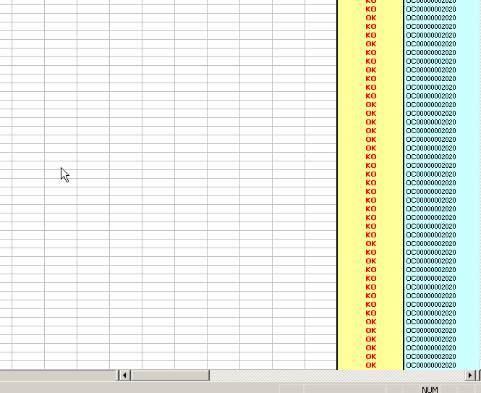

But, suddenly, if I click on the horizontal scroll bar of the excel window, as shown below, the line gets processed quite much faster.

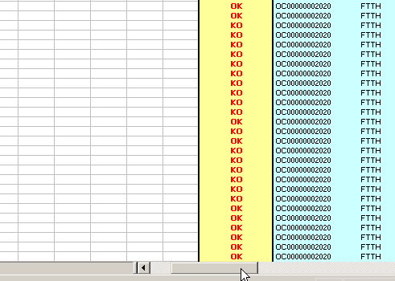
The same lines would be processed in less than 10 seconds
I just click the scroll bar without releasing the left button of the mouse.

