The following steps I have done in my company and faced the error.
- Installed .NET Framework 2.0
- Installed QTP9.2
- My application is windows based application.
- I have kept the application on “D:\NicheStreme\Manager”path.
- I have made one folder “D:\NicheStreme\QTP” path to store the results.
- Please do find here the snapshot of the followed process.

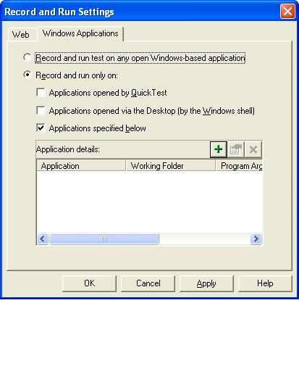

- 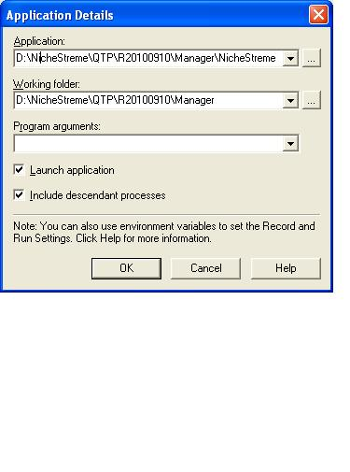
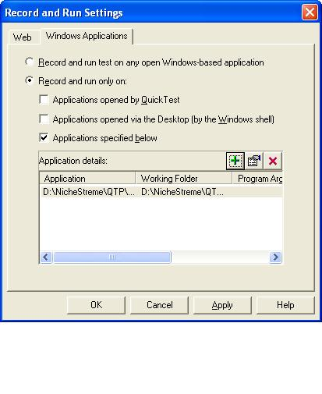

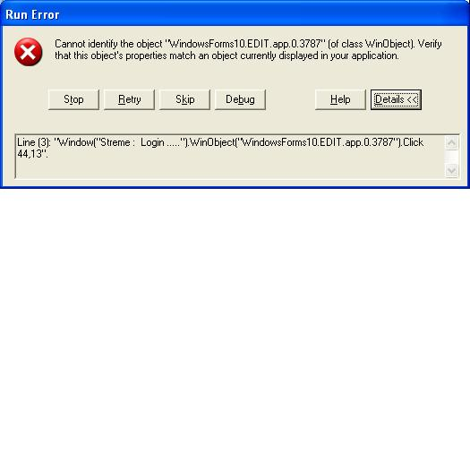

- 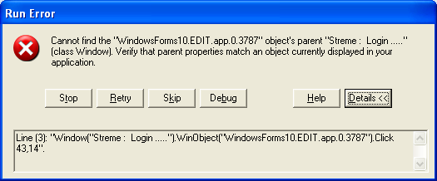

- In the “Help” section of this “Run Error”, I have the following details.
“Run Error: Cannot identify object
This error indicates that there is no object in the current view of the application that matches the description saved in the object repository for the object.
This error occurs in one of two basic situations:
- The object is not (or not yet) displayed in the application at the time of the error.
- The object is present, but the description in your application has changed so that it no longer matches the test object description that Quick Test is using to identify the object.

