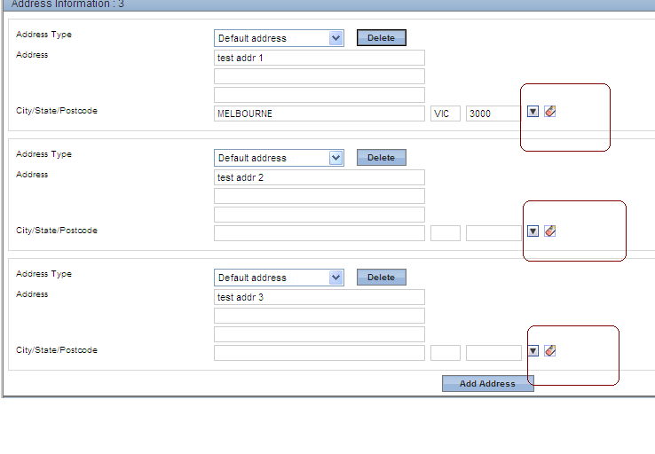

Every time the Add Address button is clicked a new occurance for the address block is displayed for user to enter address.

Please note, City and State fields are disabled. So I need to clicked on the postcode button to go to the next screen.

The ‘href ‘ field contains

javascript:crtw9165('zipCd$1', 'city$1','stCd$1','zipCd$1Dscr');

the $1 is different for each postcode button. Ie $0, $1, $2 etc…

I need to mix this field regulare expression, and some how in my script work out which postcode I am on, and change href field, so the right button is clicked.

