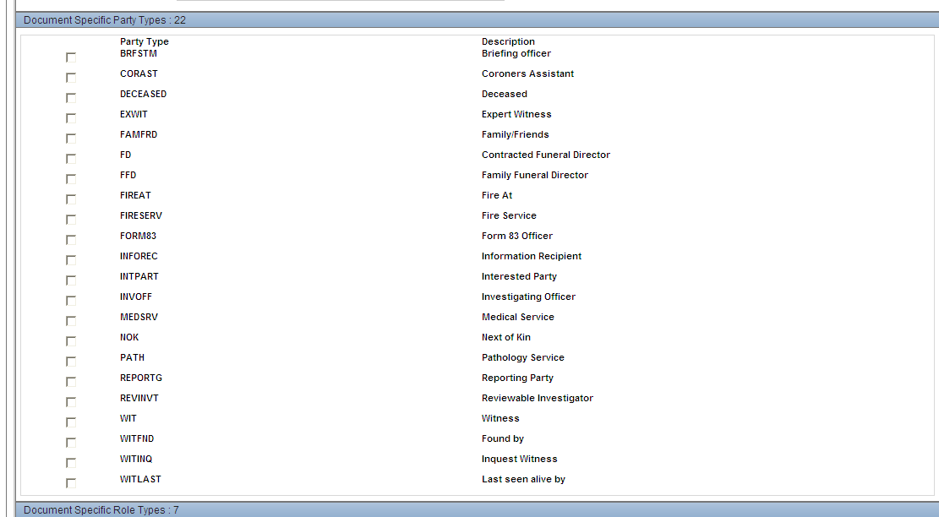

From the screen I know there are 22 party types, so in my data sheet, I will have a column FD with value = ‘ON’ and another column WIT with value = ‘ON’.

So what I want my script to be flexible, if I pick up FD with value = ‘ON’, then search the party type on the screen to find the matching one, then check the checkbox for the found one.

