Scenario ITS.0001R2 have a set of Test scripts which is called as Test set

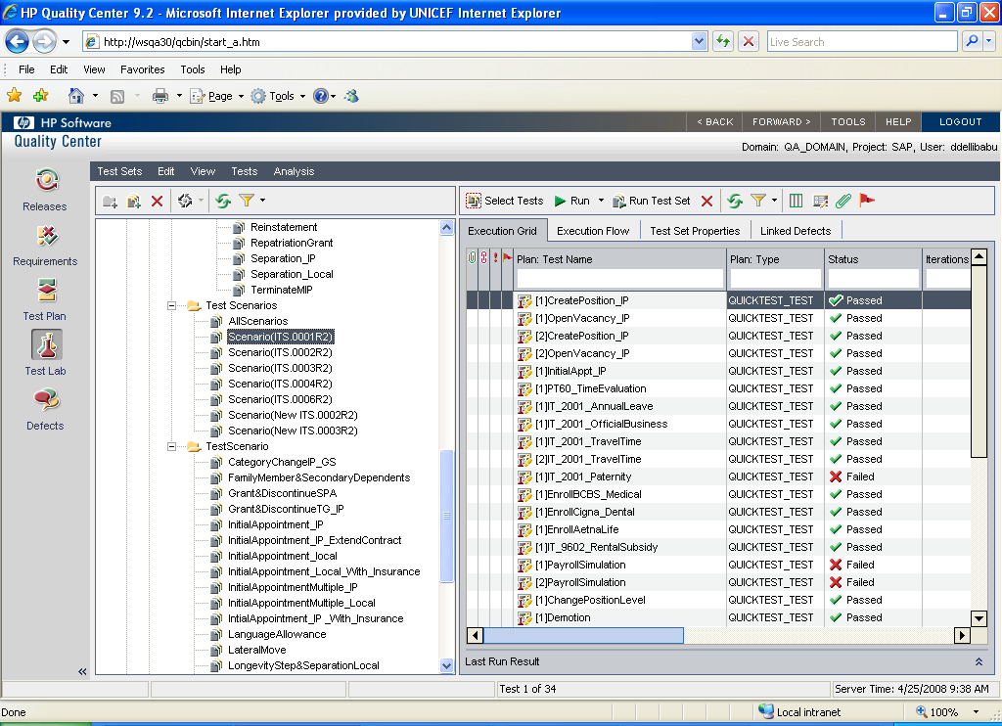

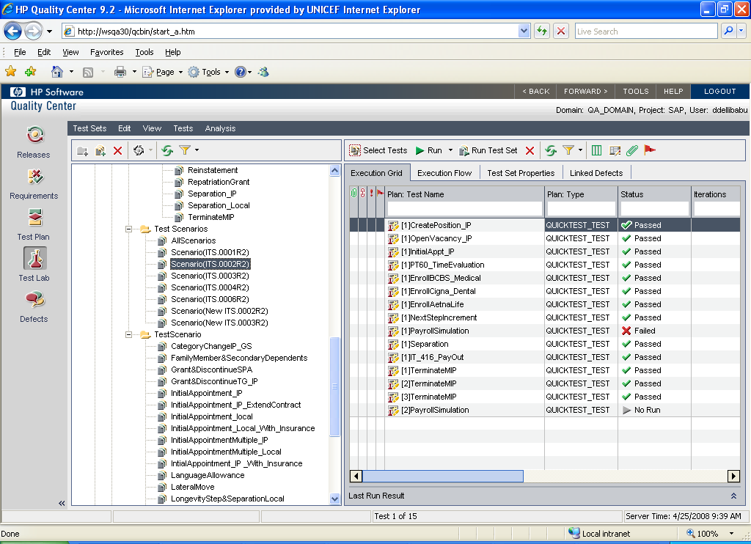

Scenario ITS.0002R2 have its own test scripts…

Now I want to run these 2 scenarios together without clicking Run everytime…

