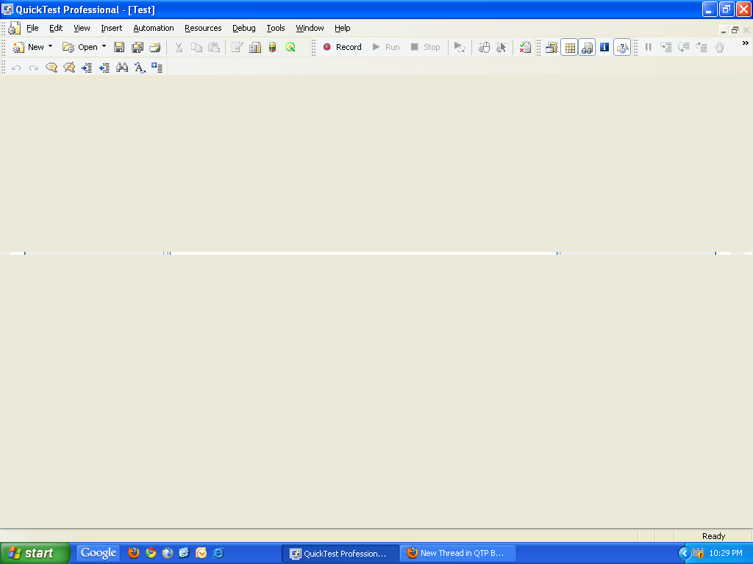

I am getting the above screen when I open QTP.

