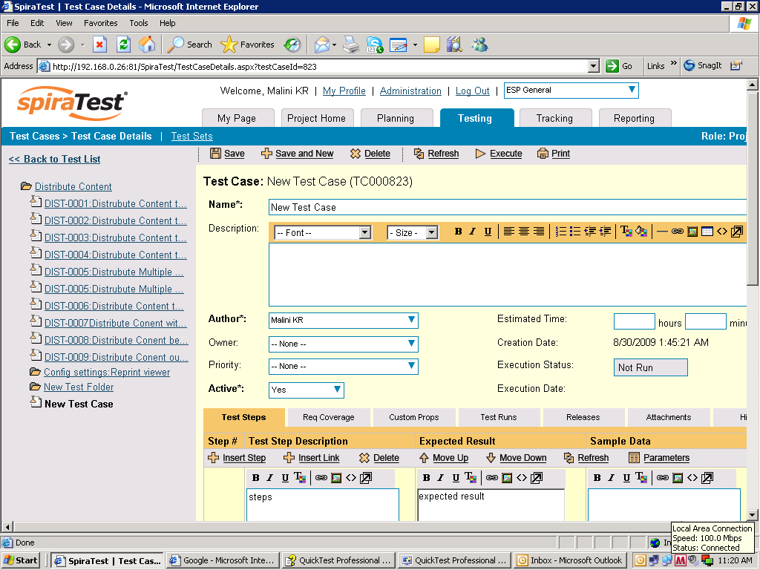
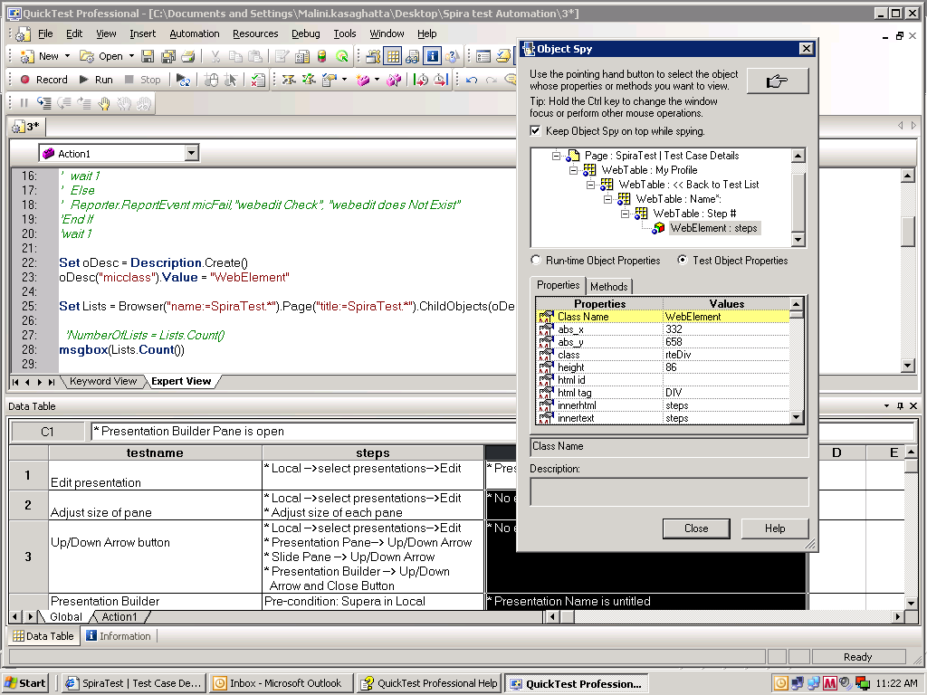
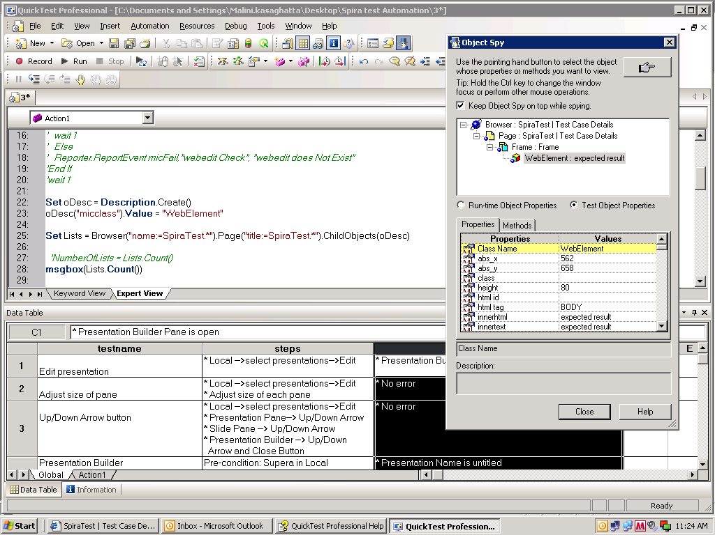
When the click occurs in the webelement, then the selection is done where we can see the blue line around the box.
In case not selected then there no blue line around the webelement which means, that the webelement is not selected.
Which means that in page 2 pict 1 before selection the obj properties are different and after clicking on the webelement, the obj properties are different.

