Initially screen appears like this:

Select the field “Area” and observe the application as in the below
Select the Value and observe the application
Click on “+” symbol and observe the application

Repeat the above steps multiple times and observe the application
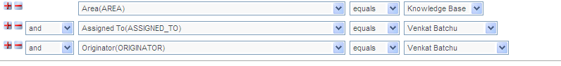

When I record the application it is taking same object multiple times like “+” is a grow button then in object repository it is taking multiple times as growbutton_1, growbutton_2, growbutton_3,…..
And the same way for the fields (area, assigned to, originator) which is taking as “Select field”, selectfield_1, selectfield_2,……

While running the application as in OR it is having multiple object and able to run successfully when I use the descriptive programming it is not running successfully

My observation:
While running the application here in the first field it is taking as Area and select the field values and next it has to perform the clicking “+” button and then it has to select the another field from the second field
Observed issue:
Here it is always selecting the first field value only instead of 2,3,4,…..

Could you please share your ideas please let me know if u have any better solution for this

