Following is the functionality:

T.Code VA01 (order type ZRE1)
There is a field named ‘billing block’ which is a combo box (drop down). The requirement in process is that while creating this transaction some value will be present (ex – 08 Check Credit Memo) and after saving this document and performing other transactions, we have to come back to the same screen by using T.Code VA02 and then, we need to change this field, by selecting blank which is there in last of the drop down list. Thus, the field ‘billing block’ should contain only blank.

Pictorial explanation:

T.Code VA01

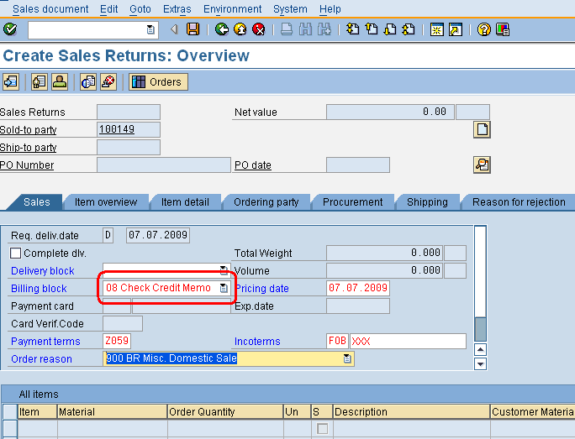

Requirement while going back to same sales order:
T.Code VA02
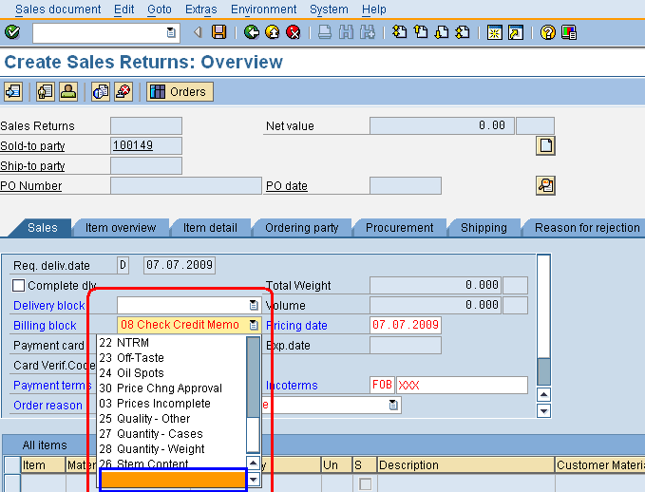

Need the object name of blank in combo box
for scripting.

Thus, in automation the following screen with blank value in the field ‘billing block’ should be the output.

