REQUIREMENT: How to get the status (fail/pass) from individual script(s) to Driver script when LoadAndRunAction is called either using output value parameters or recovery scenario test run error function call.
I have been experimenting using various ways, but not succeeded.
In Driver script, I am having LoadAndRunAction, which will call individual scripts. Here I am passing output values as parameter. I am trying with both Test and Action parameters. I even tried as Input Parameters (commented code). I am confused whether I should take as Input Parameter or Output Parameter.
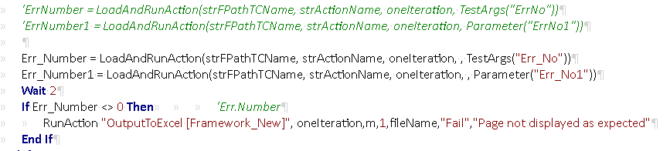
This is output parameter (Err_No) of Test of Driver script
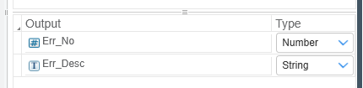
This is output parameter (Err_No1) of Action of Driver script
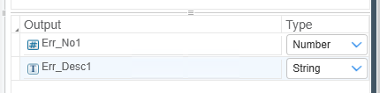
Code handled for above output parameters as below.
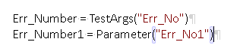
I am also creating the output parameter for individual script(s) which is turn is called by Driver script LoadAndRunAction
This is output parameter (ErrorNum1) of Test of individual script
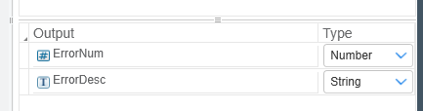
This is output parameter (ErrorNum1) of Action of individual script
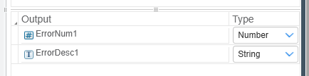
Code handled for above output parameters as below in individual script.
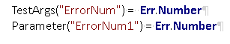
I will be getting similar kind of errors either due to test data or application issue or script issues.
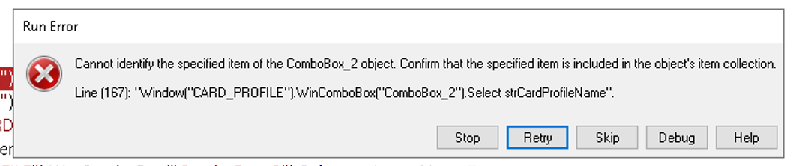
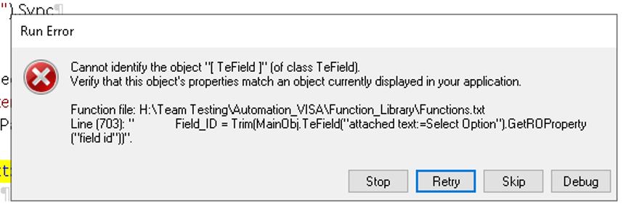
I have created 4 recovery scenarios (RS) to handle above Run Error.
TRE – Test Run Error, PW – Popup Window, FC – Function Call and KC – Keyboard Click.
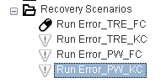
From above, only Run_Error_TRE_KC is working and it is clicking on Stop button using keys Alt +T which stops the iteration and cursor goes back to main driver script for next iteration. When cursor goes back to main driver script for next iteration, I need to get the status of execution of individual script.
In Run_Error_TRE_FC RS, I have handled the code as below. The code is in Functions Library which is associated with each script.
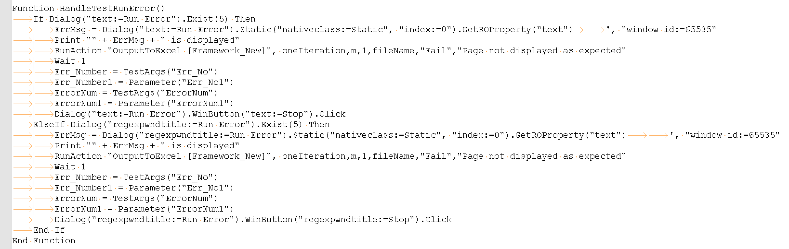
As the “Run Error” dialog box is generated by QTP due to error, we cannot spy it to get the properties, so googled and written the above code (just checking all kind of combinations).

