Descriptive Programming Code –
Set oLink=Description.Create()
oLink("micclass").value="WebButton"
oLink("html tag").value="INPUT"
oLink("type").value="submit"
oLink("class").value=" linkbtn_"
oLink("value").value="Edit"

Set LinkCount=Browser("AUS Online Banking - Batch").Page("AUS Online Banking - Batch").ChildObjects(oLink)

For n=0 to LinkCount.Count-1
LinkTitle=LinkCount(n).GetROProperty("value")
msgbox LinkTitle
If LinkTitle="Edit" Then
LinkCount(n).WebButton("name:=Edit.*","Index:=j+1").Click
Exit For
End If
Next

Code to select the Edit button based on the Index provided in the Object repository

Set oDesc=Description.Create()
oDesc("micclass").value="WebButton"
oDesc("html tag").value="INPUT"
oDesc("class").value="linkbtn_ flblinkbtn_"

Set ButtonCount=Browser("AUS Online Banking").Page("AUS Online Banking - Batch").ChildObjects(oDesc)
'msgbox ButtonCount.Count
For j=0 to ButtonCount.Count-1
'msgbox j
ButtonTitle=ButtonCount(j).GetROProperty("value")
'msgbox ButtonTitle
If ButtonTitle=DataTable("BatchDebitTempDesc","Global") Then
ButtonCount(j).Click
'Browser("AUS Online Banking").Page("AUS Online Banking - Batch").WebButton("name:=Edit","Index:=&j+1").Highlight
Browser("AUS Online Banking").Page("AUS Online Banking - Batch").WebButton("Edit_"&j+1).Click

Exit For
End If
Next

Object Repository – Edit button added multiple times until the Index 3. However, there could be many Edit buttons if there are large amount of objects on the Webpage

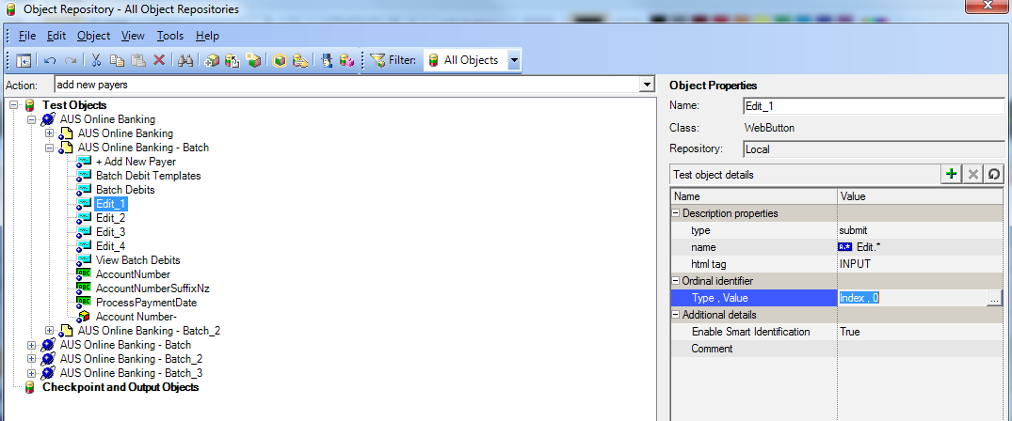

Edit_1 Button
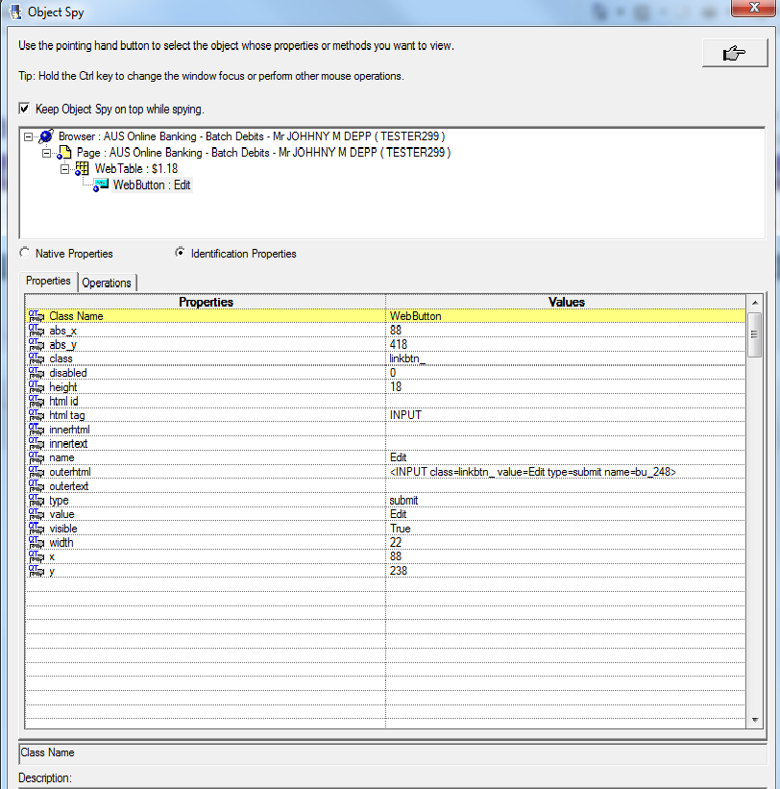

Edit_2 Button
