I am trying to automate the Jwalk Legasuite application running on AS 400 using QTP.

However during the identification of environment list, some of the characters are not recognized properly by QTP. The issue cannot be resolved as the list object is identified as ‘winobject’ and no rows or columns are identified.

Contacted HP regarding this issue, but they couldn’t offer anything as this is not a supported product by QTP.

Is there any workaround that can be implemented to resolve this issue? Any quick help is highly appreciated.

Below are the screenshots of the application and the Print log of QTP.
Thank you
Annapurna
309-648-2589
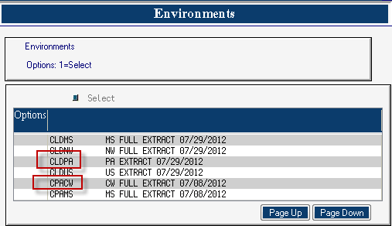

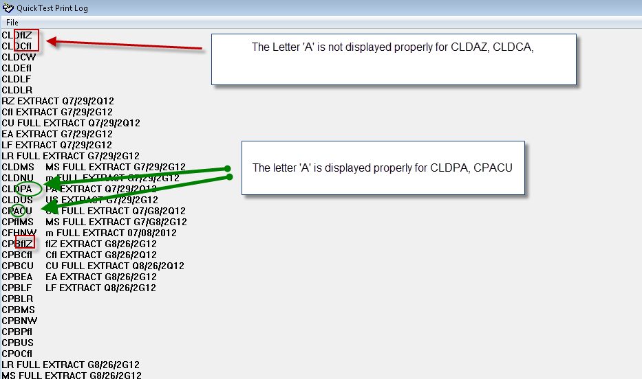

Code:

This code looks for an environment, if found highlights that environment and clicks on the continue button.

Public Function fnGUIEnvironments(strEnvironmentVal)
On Error Resume Next
Dim intLeft,intTop,intRight,intBottom,FlgEnv,i

FlgEnv=False
Do Until FlgEnv=True
intLeft=0
intTop=0
intRight=0
intBottom=0
wait(5)
Window("FTR").Window("Environments").WinObject("JWLISTLIST").GetTextLocation strEnvironmentVal, intLeft,intTop,intRight,intBottom

'Print Window("FTR").Window("Environments").WinObject("JWLISTLIST").GetVisibleText

' msgbox (Left(strenvname,4))
If intLeft AND intRight >0Then
' msgbox "exist"
FlgEnv=True
Window("FTR").Window("Environments").WinObject("JWLISTLIST").Click intTop,intBottom
wait(2)
Window("FTR").Window("Environments").WinObject("Continue").Click
ElseIf Window("FTR").Window("Environments").WinObject("Page Down").Exist(2) Then
' msgbox "Not exist"
Window("FTR").Window("Environments").WinObject("Page Down").Click
Else
Reporter.ReportEvent micFail,"Environment value "&strEnvironmentVal," Not Found"
Exit Do
End If
Loop
wait 2

If Window("Window").WinEditor("Type_Command").Exist(10) Then
Reporter.ReportEvent micDone, "Environment "&strEnvironmentVal,"Selected Successfully"
fnGUIEnvironments = True
ElseIf Window("System_Main_Menu").WinObject("Subscriber Information").Exist(10) Then
Reporter.ReportEvent micDone, "Environment "&strEnvironmentVal,"Selected Successfully"
fnGUIEnvironments = True
Else
Reporter.ReportEvent micFail, " Environment "&strEnvironmentVal,"Not Selected"
fnGUIEnvironments = False
End If

End Function

