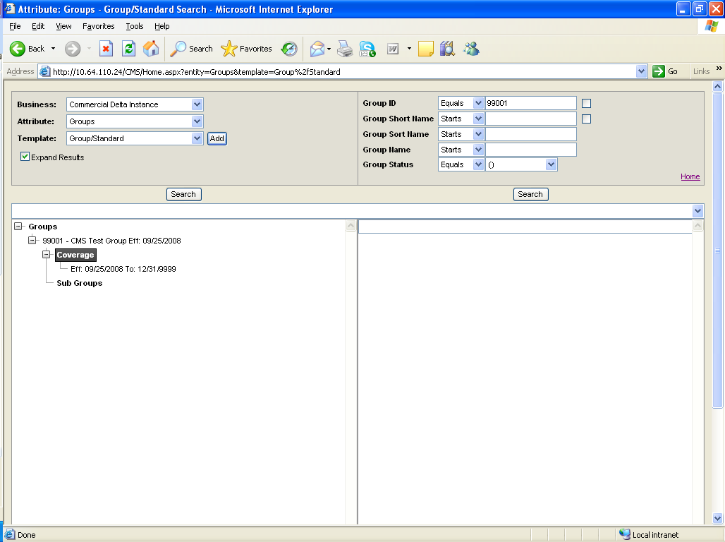

Right click on the web element “Coverage”.
A window will be displayed with some options for selection.

